David Jenkins <david.jenkins@ipwea.org>
Date: | 7 févr. 2024 02:31
Objet: | Re: IFME AM / Technical Committee - feedback required please
Dear IFME technical committee
David Jenkins | Le 22 février 2024 01:00 (
ÀChris Champion <chris.champion@ipwea.org>,
"bhavna.soni@durban.gov.za" <Bhavna.Soni@durban.gov.za>,
maurice barth <mauricebarth18@gmail.com>,
Tommie Eriksson <tommie.eriksson@ekero.se>,
"glosier@quispamsis.ca" <glosier@quispamsis.ca>,
"Paavilainen, Jyrki" <Jyrki.paavilainen@wsp.com>,
"jocksimail@me.com" <jocksimail@me.com>,
"Sibusiso.mjwara@umgeni.co.za" <Sibusiso.mjwara@umgeni.co.za>,
"Alatyppö Ville (Ville.Alatyppo@hel.fi)" <Ville.Alatyppo@hel.fi>
cc: Marc Sibbald <Marc.Sibbald@ipwea.org>,
Martina Comino <martina.comino@ipwea.org>

Objet: Re: IFME AM / Technical Committee - feedback required please

Good morning from Australia

Unfortunately, we have no registrations for this webinar. Please can you promote/market to your members?

All the details are provided below. This is a joint IFME/IPWEA webinar.

Many thanks

David Jenkins
CEO IPWEA Australasia
Phone +61 412 533 450
Web www.ipwea.org Email david.jenkins@ipwea.org
Suite 6.03, Level 6, 99 Walker Street, North Sydney, NSW 2060

Happy New Year..!

As promised, we will be running a Fleet KPI webinar. Marketing assets will follow but registrations are now open. I have also provided a small blurb:

https://www.ipwea.org/ipweacommunities/fleet-management-overview/24-fleetkpis

Please feel free to start marketing.

It is essential to manage the performance of fleet assets however unlike traditional asset management, fleet assets are mobile so the variables of kilometres travelled, or hours used, require a different set of performance management criteria. By monitoring performance, we can ensure effective, efficient and safe service delivery, identify opportunities for improvement which supports a culture of continuous improvement.

Peter Drucker (considered the father of modern management) said, “Unless we determine what shall be measured and what the yardstick of measurement in an area will be, the area itself will not be seen.”

Being seen, or included in management discussions, is one of the biggest challenges for the fleet team in any organisation. If you don’t measure the performance of your fleet assets, and share the improvements across the organisation, the fleet department won’t be seen.

In this webinar we'll share and discuss the Top 10 Fleet Management KPIs which are listed in the IPWEA Plant and Vehicle Management Manual (PVMM) which have been developed over a decade with input from asset managers.

Attendees for this webinar will receive an extract from the IPWEA Plant and Vehicle Management Manual on Key Performance Indicators.

###### https://www.ipwea.org/educationandevents/ampathway

David Jenkins
CEO IPWEA Australasia
Phone +61 412 533 450
Web www.ipwea.org Email david.jenkins@ipwea.org
Suite 6.03, Level 6, 99 Walker Street, North Sydney, NSW 2060

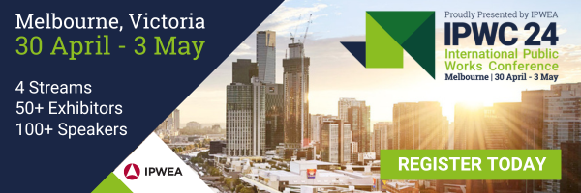
https://www.ipwea.org/ipwc/home

